**Project 6 Coin Detection – Part 1 – voting for centers**

Name: ___Michael Fatemi___ Period: ___7___ Date: ___4/12/2021___

Did you name your file l061.cpp (Lower case L, then 061)? __Yes__

Did you create the edge matrix? _____Yes______

Did you create the gradient direction matrix? _____Yes______

Did you create the imagev.ppm (visual of votes)? _____Yes______

Did you use Bresenham's line algorithm for voting? _____Yes______

Below for the easy image provided paste the imagev.ppm, imageCC.ppm you obtained running your code:

imagev.ppm:

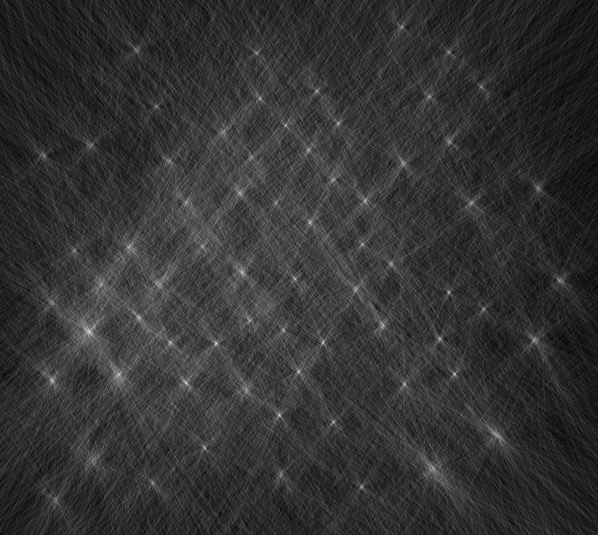

imageCC.ppm

